Product Requirements Document

Problem Statement
Clienteling is the biggest lever in luxury retail to move conversion and repeat rate. Ethos already has deep brand authority, boutique footprint, and high‑intent traffic; what’s missing is a unified, mobile‑first toolkit for advisors to personalize every interaction before, during, and after store visits.

Phase wise breakdown
Phase 1:
- Sales dashboard - Each individual staff roll up into hierarchical structure - All Store staff rolls up to HoS, HoS rolls up to HOC, HOC rolls up to ZH and ZH to NSH
  - Budget vs. Ach, LY MTD vs. MTD, LMTD vs. MTD
  - ECAL Conversion
  - ECAL Share to overall billing comparison with LY and LM
  - YTD Achievement vs. Budget and LY
- Customer Experience dashboard -
  - NPS - Last 20 score || YTD score || Last 5 remarks
  - Mystery Audit - Segment wise score (last conducted)
- Incentive Launches
  - DL sheet
  - Special incentive schemes launched
Phase 2:
- Loyalty tiers
  - LTV wise breakdown of customer segments
  - Customer data per person wise break-up || Top 10 customers of each
- Communication template and Database
  - Birthday message
  - Events invite
  - Post store visit followup
- Stock availability
  - Synced with one beat to understand availability
  - Velocity
  - Product information
Phase 3
- Incentive payout calculator
- Meeting calendar schedule sync

High-Level Approach
We will build a mobile application for store salespersons (“Advisor App”) to deliver high‑touch, personalized in‑store and post‑visit experiences that increase conversion, AOV, and lifetime value while reducing time to close.
The app centralizes Customer 360 (purchase history, preferences, key dates), live catalogue & availability, guided communication (Email/SMS/WhatsApp templates), and a real‑time Incentives Dashboard. (phase 2)
It integrates with existing POS/ERP for order capture and inventory, and with CRM/CDP for clienteling.
Why now? North‑star outcome: A trusted digital aide that helps each advisor sell smarter and faster while making every client feel known and valued.

Personas

Persona | Pain Points | Goals
Store Sales Advisor | Fragmented tools (POS/ERP/WhatsApp personal), no unified client view, slow stock checks, unclear incentives | Know the client, find right piece fast, close with confidence, follow up credibly
Store Manager | Low visibility of advisor activity, incentives opaque, quality of follow‑ups varies, understanding of customer experience gaps is periodic | Coach team, forecast & hit targets, assign leads, ensure compliance
CRM/Marketing Admin | Inconsistent messaging, consent management gaps, poor attribution | Template governance, segmentation, campaign hygiene
Client (Customer) | Repeating info, generic messages, unclear availability/status | Feel known & advised, not sold to; smooth purchase & after‑sales

User Stories

Platform - Android and iOS

Advisor
- I will sign in with my Ethos employee credentials(registered in HRMS) and unlock with PIN/biometrics so that I can start selling quickly and securely
- I want to access a unified customer profile (history, product preferences, key dates, consent) so that I can tailor recommendations. [Profile loads <2s with last 10 purchases; consent flags block non‑permitted channels]
- I will enter product details/scan a watch barcode/QR and open the SKU product page/card instantly so that I can keep momentum with the client.
- I want to share a payment link via WhatsApp/SMS/Email so that the client can pay online or in-store by POS - Integrating payment link with CRM - Facility already under development
- I want to reserve stock against an active quote so that availability is guaranteed while the client decides. [Reserve timer visible; release on expiry or cancel] - VC Report and credit billing report
- I want company‑approved templates with auto‑filled variables so that I can send polished outreach quickly with channel enforcement (consent, DND, quiet hours) so that I remain compliant. Types of Templates -
  - Occasion: Birthday, Anniversary, Festive greetings + curated picks. (Club echo)
  - Follow‑ups: Tried in store, Quote reminder, Back‑in‑stock.
  - Education: Care guide, Brand story, How to choose your size.
- I want a daily to-do list (birthdays, anniversaries, quote follow‑ups) so that I never miss critical moments.
- I want a target vs achieved dashboard so that I know how far I am from my goal (along with a commission estimator tied to my quote) so that I understand expected my alignment with budgeted targets . [Current month target/actual/variance; updates hourly]
- I want a dashboard showing my last achieved score in the Mystery Audit conducted so as to better understand my delivery of customer experience.
- I want a structured dashboard showing my NPS scores over definitive time frames - Over the last 20 received feedbacks, and YTD. Also, highlight last 5 received comments, so that we can keep track of every individual feedback
- I want to create appointments and send invites so that clients remember to visit.

Admin & Governance
- I want to manage templates and suppression policies so that messaging is consistent and compliant. [Tagging, approval, quiet hours, and channel suppression configurable]
- I want audit trails for profile edits, sends, and reserves so that investigations are straightforward. [Actor, timestamp, entity, and changes recorded] - To show last invited event

Prototype [For Design Reference]

V1.0

https://chatgpt.com/canvas/shared/68cbd05500548191816f07dd4826918a

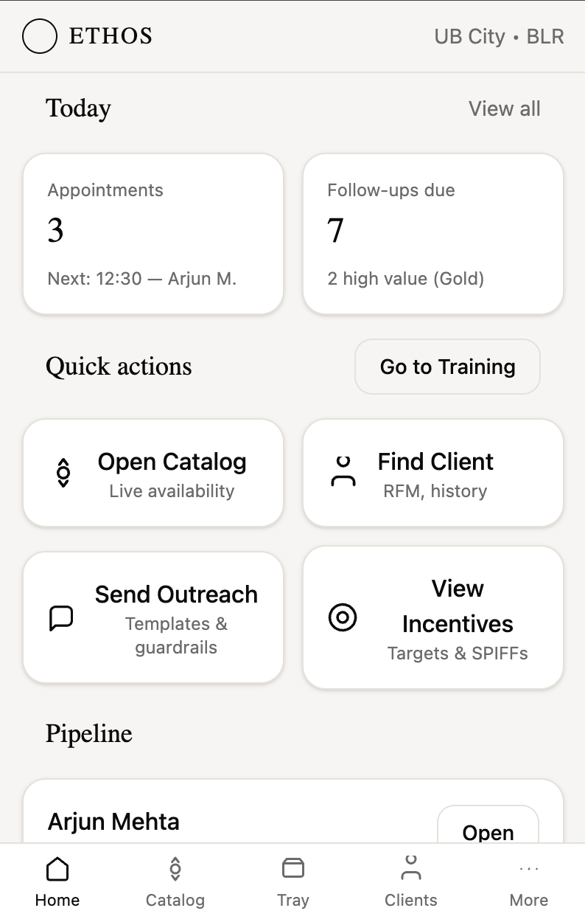
V1.1 [Phase 1] -
https://chatgpt.com/canvas/shared/68d615d72b7c819187e26a295843837a

Goals (In order of priority)
- Improve repeat purchase & visit rate using automated but personalized follow‑ups tied to moments (birthday/anniversary/service due/new collection drops).
- Increase in‑store conversion rate via better qualification, tailored recommendations, and rapid access to stock & alternatives.
- Lift AOV by structured cross‑sell (straps, service plans, insurance, accessories) and intelligent bundles.
- Reduce advisor time‑to‑close with instant availability, barcode/QR scan to SKU card, quick quote & payment link flows.
- Drive advisor productivity & morale with a transparent Achievement Dashboard (targets vs actuals, growth trends, leaderboards) and smart nudges.

Non‑Goals (Not in Scope)
- Building a full POS replacement (we will augment current POS/ERP, not rebuild). - POS integration, currently none
- Service/Repair workshop management beyond booking/intake & status view.
- Full loyalty program revamp (we surface current tiers/benefits in Customer 360).

Guardrails
- Privacy & consent first (DPDP 2023 compliant). Opt‑in tracking, explicit consent capture & granular channel preferences. Honor DND lists.
- Brand compliance: All outreach uses pre‑approved message templates; tone & visuals consistent with luxury positioning and brand partner rules.
- Operational integrity: No messaging to customers outside business hours unless scheduled by the customer; rate‑limit & suppression rules applied.

Open Questions (to resolve in Discovery)

- Brand partner constraints on imagery/pricing for sharing over WhatsApp/ SMS/Email - Discounts not to be triggered via message
- Exact DND/quiet hours policy by city/format (malls vs boutiques)
- Returns/ Refund Policy impact on communication

Execution Master

Sales App - Execution Master

